Introduction to Machine Learning

Machine Learning is a technique that allows computers to learn from data and make decisions without explicit programming. It works by identifying patterns in data and using them to make predictions. It is used in areas such as:
- Image Recognition
- Speech Processing
- Language Translation
- Recommender Systems
Need for Machine Learning
Machine Learning is important because traditional programming cannot handle complex tasks or large amounts of data efficiently. ML overcomes this by learning from data and making predictions without fixed rules. It is needed for the following reasons:

1. Solving Complex Business Problems
Traditional programming struggles with tasks like language understanding and medical diagnosis. ML learns from data and predicts outcomes easily.
Examples:
- Image and speech recognition in healthcare.
- Language translation and sentiment analysis.

2. Handling Large Volumes of Data
The internet generates huge amounts of data every day. Machine Learning processes and analyzes this data quickly by providing valuable insights and real time predictions.
Examples:
- Fraud detection in financial transactions.
- Personalized feed recommendations on Facebook and Instagram from billions of interactions.

3. Automate Repetitive Tasks
ML automates time consuming, repetitive tasks with high accuracy hence reducing manual work and errors.
Examples:
- Gmail filtering spam emails automatically.
- Chatbots handling order tracking and password resets.
- Automating large scale invoice analysis for key insights.

4. Personalized User Experience
ML enhances user experience by tailoring recommendations to individual preferences. It analyze user behavior to deliver highly relevant content.
Examples:
- Netflix suggesting movies and TV shows based on our viewing history.
- E-commerce sites recommending products we're likely to buy.

5. Self Improvement in Performance
ML models evolve and improve with more data helps in making them smarter over time. They adapt to user behavior and increase their performance.
Examples:
- Voice assistants like Siri and Alexa learning our preferences and accents.
- Search engines refining results based on user interaction.
- Self driving cars improving decisions using millions of miles of driving data.

How Machines Learn from Data
A machine learns by finding patterns in data and improving over time without explicit programming. It adapts with experience to make more accurate predictions. This learning happens through the following steps:
- Data Input: Machine needs data like text, images or numbers to analyze. Good quality and enough quantity of data are important for effective learning.
- Algorithms: Algorithms are mathematical methods that help the machine find patterns in data. Different algorithms help different tasks such as classification or regression.
- Model Training: During training, the machine adjusts its internal settings to better predict outcomes. It learns by reducing the difference between its predictions and actual results.
- Feedback Loop: Machine compares its predictions with true outcomes and uses this feedback to correct errors. Techniques like gradient descent help it update and improve.
- Experience and Iteration: Machine repeats training many times with data helps in refining its predictions with each pass, more data and iterations improve accuracy.
- Evaluation and Generalization: Tested on new data to ensure real world performance
Data is the foundation of machine learning because models learn patterns and make predictions from it. Good quality and diverse data help improve accuracy, performance and real-world results.

Types of Machine Learning

Machine Learning (ML) is a subfield of Artificial Intelligence (AI) that focuses on building algorithms and models that enable computers to learn from data and improve with experience without explicit programming for every task. In simple words, Machine Learning teaches systems to learn patterns and make decisions like humans by analyzing and learning from data.
There are several types of machine learning, each with special characteristics and applications. Some of the main types of machine learning algorithms are as follows:
- Supervised Machine Learning
- Unsupervised Machine Learning
- Reinforcement Learning
Additionally, there is a more specific category called Semi-Supervised Learning and Self-Supervised Learning, which combines elements of both supervised and unsupervised learning
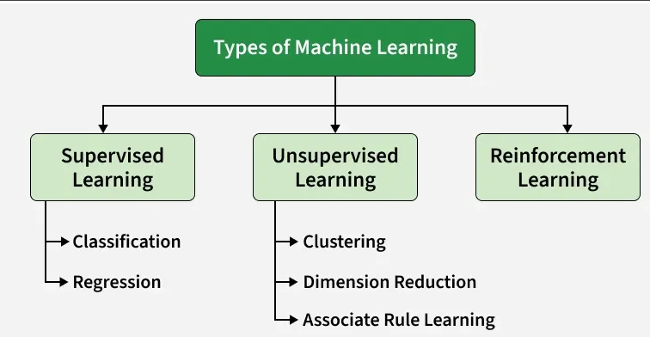
Types of Machine Learning

1. Supervised Machine Learning
Supervised learning is defined as when a model gets trained on a "Labeled Dataset". Labelled datasets have both input and output parameters. In Supervised Learning algorithms learn to map points between inputs and correct outputs. It has both training and validation datasets labelled.
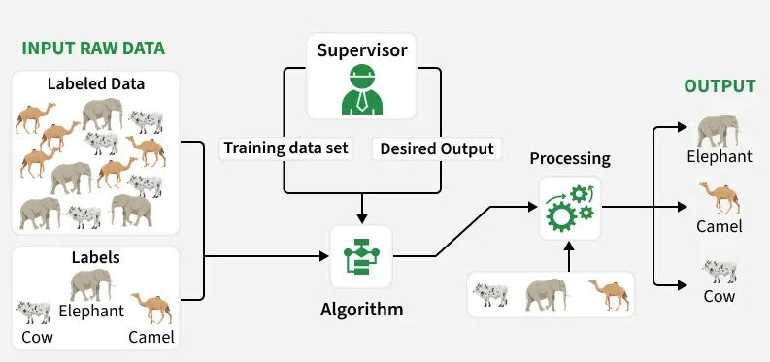
Supervised Learning
Example: If you train a model using labeled images of cats and dogs, it learns the features of each. When shown a new image, it predicts whether it’s a cat or a dog.
There are two main categories of supervised learning that are mentioned below:

1. Classification
Classification predicts categorical outputs, meaning it assigns data into predefined classes like spam/non-spam emails or disease risk categories. These algorithms learn to map input features to discrete labels. Here are some classification algorithms:
- Logistic Regression
- Decision Tree
- Random Forest
- K-Nearest Neighbors (KNN)
- Naive Bayes
- Support Vector Machine

2. Regression
Regression, predicts continuous values, such as house prices or product sales. It learns the relationship between input features and a numerical target variable. Here are some regression algorithms:
- Linear Regression
- Polynomial Regression
- Ridge Regression
- Lasso Regression
- Decision tree
- Random Forest

Where to Use Supervised Learning
- When you have labeled data and want to predict outcomes.
- Ideal for classification (like spam detection) or regression tasks (like price forecasting).
- Best used in domains where historical data with outcomes is already available.

Applications
Supervised learning is used in a wide variety of applications, including:
- Image, speech and text processing: For tasks like image classification, speech recognition and sentiment analysis.
- Predictive analytics: To forecast sales, customer churn, stock prices and weather conditions.
- Recommendation and personalization: Powering systems that suggest products, movies or content.
- Healthcare and finance: Used for medical diagnosis, fraud detection and credit scoring.
- Automation and control: In autonomous vehicles, manufacturing quality checks and gaming AI.

2. Unsupervised Machine Learning
Unsupervised Learning works with unlabeled data, meaning there are no predefined outputs. The algorithm finds hidden patterns, groups or relationships within the data on its own. It’s mainly used for clustering, dimensionality reduction and data visualization.
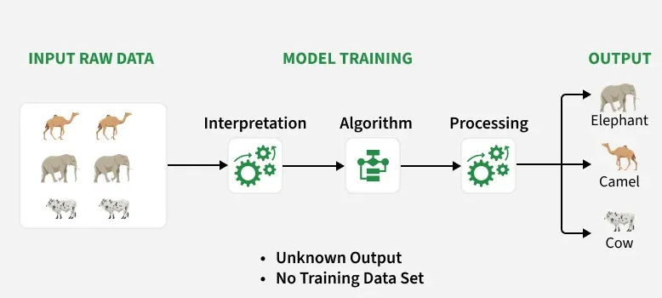
Unsupervised Machine Learning
Example: If you have customer data without labels, the algorithm can group similar customers based on purchase behavior useful for segmentation and marketing.
There are two main categories of unsupervised learning that are mentioned below:

1. Clustering
Clustering is the process of grouping data points into clusters based on their similarity. This technique is useful for identifying patterns and relationships in data without the need for labeled examples. Common techniques include:
- K-Means
- DBSCAN
- Mean-shift

2. Dimensionality Reduction Techniques
Dimensionality reduction helps reduce the number of features while preserving important information. Common techniques include:
- Principal Component Analysis
- Independent Component Analysis

3. Association Rule Learning
Association rule learning is a technique for discovering relationships between items in a dataset. It identifies rules that indicate the presence of one item implies the presence of another item with a specific probability. Common techniques include:
- Apriori
- FP-growth
- Eclat

Where to Use Unsupervised Learning
- When data is unlabeled or unstructured.
- Useful for exploratory analysis, clustering or feature extraction.
- Common in marketing, recommendation systems and fraud detection where patterns matter more than labels.

Applications of Unsupervised Learning
Here are some common applications of unsupervised learning:
- Clustering and segmentation: Group similar data points, customers or images.
- Anomaly detection: Spot unusual patterns or outliers in data.
- Dimensionality reduction: Simplify large datasets while retaining key information.
- Recommendation and marketing: Identify user preferences and improve product suggestions.
- Data preprocessing and analysis: Clean data, detect patterns and support exploratory data analysis (EDA).

3. Reinforcement Learning
Reinforcement learning trains an agent to make a sequence of decisions through trial and error. The agent interacts with the environment, receives feedback in the form of rewards or penalties and learns optimal actions over time.

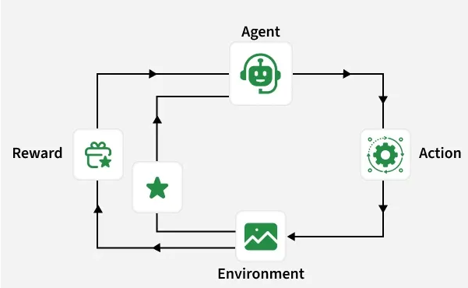
Reinforcement Machine Learning
Example: An AI agent learning to play chess gets positive feedback for good moves and negative for poor ones. Over time, it learns strategies to win more often.
Here are some of most common reinforcement learning algorithms:
- Q-learning: Learns the best action for each state based on expected rewards.
- SARSA (State-Action-Reward-State-Action): Similar to Q-learning but updates values for the action actually taken.
- Deep Q-learning: Uses neural networks to handle complex state-action relationships

Types of Reinforcement Learning
- Positive Reinforcement: Rewards desired behavior (e.g., giving points for correct answers).
- Negative Reinforcement: Removes negative outcomes to encourage good actions (e.g., turning off a buzzer after the right move).

Where to Use Reinforcement Learning
- When you need an agent to learn by interacting with an environment.
- Best for decision-making or optimization tasks involving trial and feedback loops.
- Used when long-term performance or adaptive behavior is more important than immediate accuracy.

Applications of Reinforcement Learning
Here are some applications of reinforcement learning:
- Gaming and simulation: Teaching agents or NPCs to play and adapt intelligently.
- Robotics and automation: Enabling robots to perform tasks autonomously.
- Autonomous vehicles: Helping self-driving cars make real-time decisions.
- Healthcare and finance: Optimizing treatment plans, trading and resource allocation.
- Recommendation and personalization: Improving user experience through adaptive suggestions.
- Industrial and energy management: Optimizing control systems and energy use.

Semi-Supervised Learning: Supervised + Unsupervised Learning
Semi-Supervised learning Semi-Supervised Learning combines both Supervised and Unsupervised approaches. It uses a small set of labeled data and a large set of unlabeled data for training useful when labeling is costly or time-consuming.
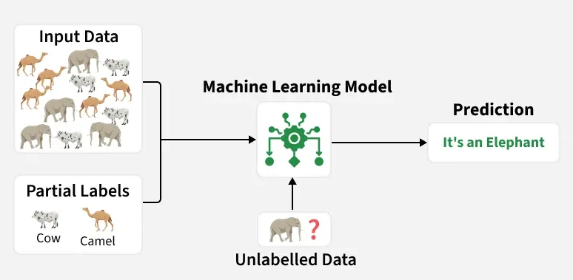
Semi-Supervised Learning
Example: Consider that we are building a language translation model, having labeled translations for every sentence pair can be resources intensive. It allows the models to learn from labeled and unlabeled sentence pairs, making them more accurate. This technique has led to significant improvements in the quality of machine translation services.

Popular Techniques
- Graph-based Learning: Spreads label information through data relationships.
- Label Propagation: Iteratively assigns labels to unlabeled data.
- Co-training: Uses two models to train and label each other’s data.
- Self-training: Uses model predictions as pseudo-labels.
- Generative Adversarial Networks (GANs): Generates synthetic data to improve learning.

Where to Use Semi-Supervised Learning
- When you have limited labeled data but plenty of unlabeled data.
- Useful for domains with high labeling costs, such as medical, NLP or image datasets.
- Ideal when unlabeled data still holds valuable information that can improve learning performance.

Applications
- Image Classification: Combine small labeled and large unlabeled image datasets to improve accuracy.
- Natural Language Processing (NLP): Enhance language models by using a mix of labeled and vast unlabeled text data.
- Speech Recognition: Boost accuracy by leveraging limited transcribed audio and more unlabeled speech data.
- Recommendation Systems: Improve recommendations using sparse labeled data and abundant unlabeled user behavior.
- Healthcare & Medical Imaging: Improve medical image analysis with a mix of labeled and unlabeled images.

Popular Techniques
- Masked Modeling (BERT)
- Contrastive Learning (SimCLR, MoCo)
- Autoencoders
- Predictive Coding

Applications
- Natural Language Processing
- Computer Vision and Speech Recognition
- Video understanding
- Pre-training for large AI models

Where to Use Self-Supervised Learning
- When manual labeling is impossible or expensive.
- Suitable for large-scale datasets like text, audio and images.
- Best for pre-training models that can later be fine-tuned for specific supervised tasks.

Comparison
Type | Data Requirement | Label Availability | Learning Goal | Common Use Case
Supervised | High | Labeled | Predict outputs | Spam detection, Price prediction
Unsupervised | Medium | Unlabeled | Find hidden patterns | Customer segmentation
Reinforcement | High | Reward feedback | Learn best actions | Robotics, Games
Semi-Supervised | Medium | Partial labels | Combine both learning types | NLP, Image recognition

Benefits of Machine Learning
Machine Learning improves processes by automating tasks and extracting insights from data, making systems smarter and more efficient.
- Automates repetitive tasks and improves productivity
- Finds patterns in large data for better decisions
- Provides customized recommendations and experiences
- Enables robots and systems to perform complex tasks accurately

Challenges
- ML models learn from training data and if the data is biased, model’s decisions can be unfair so it’s important to select and monitor data carefully.
- Since it depends on large amounts of data, there is a risk of sensitive information being exposed so protecting privacy is important.
- Complex ML models can be difficult to understand which makes it difficult to explain why they make certain decisions. This can affect trust and accountability.
- Automation may replace some jobs so retraining and helping workers learn new skills is important to adapt to these changes.

Applications
- In healthcare it diagnoses diseases, predicts outcomes and personalizes treatments
- In finance detects fraud, supports trading and assesses credit risk
- Recommends products, forecasts demand and analyzes customer behavior
- Powers self-driving cars, optimizes routes and predicts maintenance
- Recommends content and enables image/speech recognition
- Detects defects and predicts machine failures

